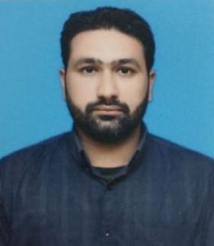**MUSAB AQEEL SHAKIR**

MUSLIMABAD

GUJRAT, PAKISTAN

Cell # 0334-4657946

musabaqeel@gmail.com

## CAREER OBJECTIVE

To be a part of professional team at reputed organization utilizing my abilities for the fulfillment of organization’s as well as personal career growth.

## PROFESSIONAL EXPERIENCE

* **EDUCATION DEPARTMENT**

Working in the cadre of EST in school education department

April-2012 to MAY 2023

Working in the cadre of SST in school education department

JUNE 2023 till now

## ACADEMIC QUALIFICATION

* **M.S.**

Degree: M.S. (Physics)

University: University of Lahore (Gujrat campus)

CGPA: 3.20

* **M.Sc.**

Degree: M.Sc. (Physics)

University: GC University Faisalabad

CGPA: 3.04

* **B.Sc.**

Degree: B.Sc. (Math A+B, Physics)

College: Govt. Zamindar College Gujrat

University: University of Gujrat

Marks: 58.4%

* **HSSE**

Degree: FSc (Pre-Engg)

College: Govt. Zamindar College Gujrat

Board: BISE (GRW)

Marks: 56.5%

* **SSC**

Degree: Matriculation

School: Municipal Model High School Gujrat

Board: BISE (GRW)

Marks: 74%

## PROFESSIONAL QUALIFICATION.

* **B.Ed.**

Degree: B.Ed (Math + Physics)

University: University of Sargodha

Marks: 55%

## COMPUTER SKILLS

* Hardware knowledge of all computer equipment’s.
* Programming in C++
* Practical skills of Electronics lab
* Microsoft Office

**LANGUAGE**

Proficiency & fluency in English, Urdu and Punjabi.

**PERSONALITY**

* Strong communication.
* Believe in hard work.
* Always try to with all team members.
* Creative mind and thinking.
* Like to work in challenging & professional environment.
* Punctual.
* Cool minded & can handle difficult situations easily.

**HOBBIES AND INTEREST**

* Love to read news.
* Listening music.

**EXTRACURRICULAR ACTIVITIES**

* Arranged recreational tours in my university
* Assisted in organizing of arranging Farewell and Welcome parties in universities
* Participate in dramatic activities of institution.

**REFFERENCE**

To be provided on request.