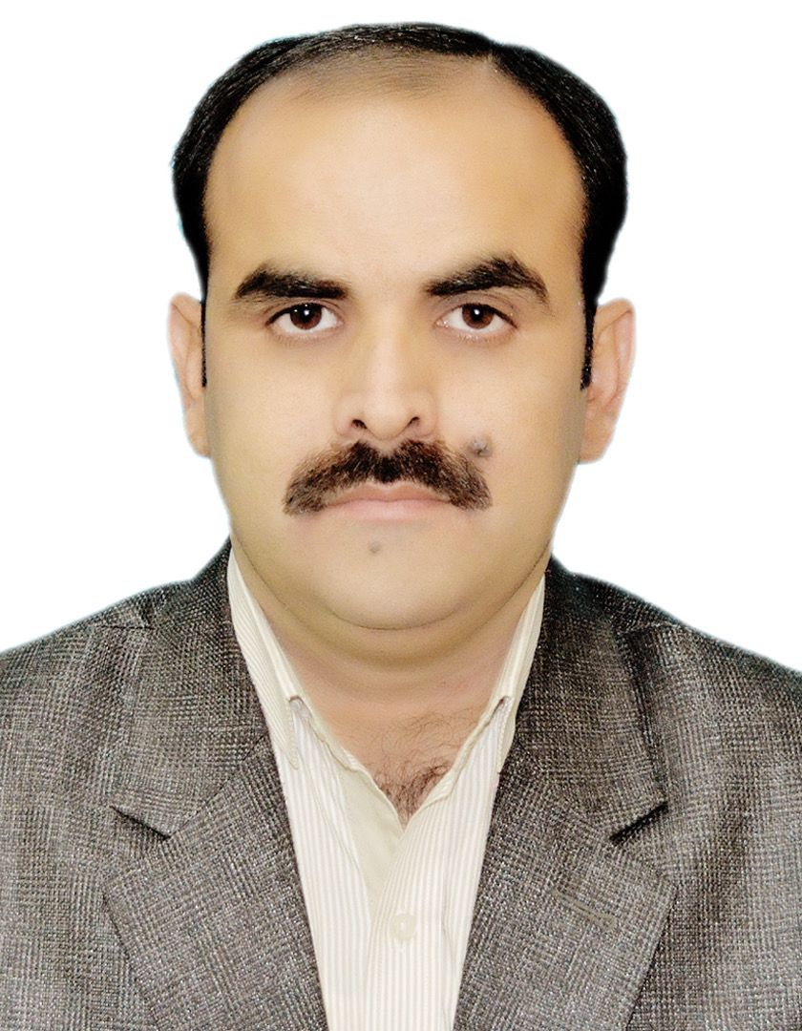 | Naseem Ajaz
CONTACT DETAILS  Address  Sattelite Town Block No 5 Nasserabad Road Quetta Balochistan.  Phone number  03338283178  03358367914  Email  Info.pefh@gmail.com  Personal Skills  - Excellent communication skills.  - Excellent leadership, motivational, analytical.  - Excellent management and negotiation skills.  - Excellent report writing skills  Languages  - English  - Urdu  - Balochi  - Brahvi  - Persian  Expertise Area  - Management  - Planning  - Reporting  - Training Delivering  - Team Survillance  - Computer Operating  - Communication Skills  Computer Skills:  - Microsoft Office  - Internet  - Software & programming  - Abacus Airline program.  - G boss online Accounting System.  - Whiz men Accounting System | PROFILE  Professionals who aim to enhance overall well-being and help meet basic and complex needs of communities and people. Social workers work with many different populations and types of people, particularly focusing on those who are vulnerable, oppressed and living in poverty.  Working as a social worker and Master Trainer with more than 15 years of experience in Health sector, Administration,Emergency Relief Response, Team Management. Committed, Negotiation skills. Proven ability to achieve Every Targets and significantly results oriented, motivated and focused on field related activities.  PROFESSIONAL EXPERIENCE  District Data Analyst, World Health Organization , Jaffarabad, Pakistan.  January 2022 – Till Sep 2024  - VPD surveillance data is compiled, analyzed and shared with DHMTs and Ucs on weekly basis.  - Line list is regularly reviewed and updated in MIS and Excel.  - Report on all OBs prepared and shared,  - Minutes of Monthly review meeting prepared and shared with DO.  - Developing and sharing of monthly district bulletin with brief data analysis of coverage, surveillance.  - Supported TO, DOs and DDSOs in all assigned tasks.  - Monthly all WHO supported Vaccination evaluation reported/consolidation report/ Performance report prepared on the given format.  Union Council Polio Worker, World Health Organization , Quetta, Pakistan.  January 2019 – Till may 2021  - Arrange Meetings of Community Elders Religious Leaders Political Workers of the Said Union Council 13 B Eastern By Pass Quetta Balochistan.  - Arrange Training's for LHW’s and Polio Worker with the help of UCMO Government Representatives.  - Making Maps of the concern Union Council Including Legends all the related Data.  - Making reports Collecting Data Taking Clusters review them separately also taking follow ups from union council,  - Direct reporting to PEO Polio Eradication Officer.  - Social Mobilization Process to be followed in religious Factor Political Factor follow up refusals report them with UCMO also with UNICEF Team.  General Manager Operations,Peaceful Environment for Humanity,Quetta, Baluchistan.  January 2012 - December 2018  - Determine staffing requirements, and interview, hire and train new employees, or oversee those personnel processes.  - Monitor organizational policy, goals, objectives, with board members, organization officials, and staff members as necessary.  - Plan and monitor the programs overall progress, Resolve any issues and instigate corrective action as appropriate (Issues management and analysis).  - Monitoring budget on behalf of the program section and costs against deliverable and realized benefits as program develops  - Monitor organizations and agencies to ensure that they efficiently and effectively provide needed services while staying within budgetary limits.  - Oversee activities directly related to making products or providing services.  - Monthly attending board meeting  Admin and Finance Officer, Women Development Organization, Quetta, Pakistan.  January 2011 - December 2011  - Maintain day-to-day financial control of the service within budget heads agreed by the trustee board.  - Make regular reports to the governing body on income, expenditure and any variations from budgets.  - Responsible for all Payments Transportation, fuel, salary, and office and utility bills payments.  - Maintain expenses files on monthly basis with verification of supervisor and also fuel records on weekly basis staff salaries, labor payments, and transportation payments as well as maintain records each and every single transaction in the organization.  - Develop and oversee appropriate publicity through effective relations with the media, other community organizations and through public speaking.  Admin and Finance Officer, Baluchistan Boys Scouts Association, Quetta, Pakistan.  January 2010 - December 2010  - Update cashbook, cash count; float register and salary advance register in time.  - Prepare salary slips and assist in preparation of payroll.  - Prepare and assist in preparing month end reports.  - Monitor the labor payments.  - Responsible for all Payments Transportation, fuel, salary, and office and utility bills payments.  - Preparation of weekly & Monthly reports in co-operation with the Regional Coordinator of financial records of ongoing projects in Regional Head Office Jaffarabad.  - Update the daily expenses Formats of fuel, office expenses, and purchasing equipment’s from shopkeepers.  Admin and Finance Officer, Taraqee Foundation, Quetta, Pakistan.  January 2009 - December 2009  - Worked in WFP project in Flood Relief Emergency in District Naseerabad providing food assistance to the IDP’s affected from flooded Areas.  - Worked in UNHCR project in Flood Relief Emergency in District Naseerabad and jaffarabad providing Shelters to the IDP’s affected from flood.  - Responsible for all administrative tasks and duties within the Department.  - Reception and dispatching of all incoming and outgoing documents, letters, messages, etc. for the Department.  - Preparation of weekly reports in co-operation with the Car Dispatcher concerning mileage, fuel, consumption and service schedules of the fleet.  - Supervision of warehouse staff and recruitment of labors for loading and unloading.  - To manage material for fields required for distribution and implementation of field activities according to schedule of field staff/ Correspondence and transport arrangement.  - Management of goods (receipt and allocation, handling, storage, ration) with the assets of in warehouse.  - Preparation and Filling of payment and receipt vouchers/Update cashbook, cash count; float register and salary advance register in time/ labor payments.  Admin Internee, Centre for Peace and Development, Quetta, Pakistan.  July 2008 - December 2008  - Working experience in Center for Peace and Development Quetta as Admin officer and Experienced about, Financial Reporting, Provide travel information including per Diem rates and hotel listing,  - Maintain training information.  - Responsible for all administrative tasks and duties within the Department.  - Reception and dispatching of all incoming and outgoing documents, letters, messages, etc. for the Department.  - Preparation and Filling of payment and receipt vouchers.  - Update cashbook, cash count; float register and salary advance register in time.  - Prepare salary slips and assist in preparation of payroll.  - Prepare and assist in preparing month end reports.  Admin Internee, South Asia Partnership Pakistan, Quetta, Pakistan.  January 2008 - June 2008  - During (6) Months in South Asia Partnership I work and learn about Finance Section in this particular area I gained a lot of experience about online system used in NGOs Sector and about Daily Entries, Bank Reconciliation Statement, Journal General, Vouchers, Book keeping and Tax Deduction Formats during my Internship Program.  - Dispatching material record keeping.  - Correspondence and Transport Arrangement.  - Procurement staff food and office material.  - Preparation and Filling of payment and receipt vouchers.  - Update cashbook, cash count; float register and salary advance register in time.  - Prepare salary slips and assist in preparation of payroll.  - Prepare and assist in preparing month end reports.  - Responsible for all administrative tasks and duties within the Department.  - Reception and dispatching of all incoming and outgoing documents, letters, messages, etc. for the Department.  Educational History in Baluchistan,Pakistan.  Matriculation School Certificate  Baluchistan Broad of intermediate of Education  Obtained 2nd Division  Science Subjects  Secondry School Certification  Baluchistan Broad of intermediate of Education  Obtained 2nd Division  Science Subjects  Higher Secondary School Certification  University Of Baluchistan  Bachelors of Arts  Obtained 2nd Division  Economics  Post Graduation Degree  University Of Baluchistan  Obtained 2nd Division  International Relations  Work Shops & Training's  - B.E.F.A.Re QUETTA  Attend Two (2) days Training (15-16 April 2009) in Counter Human Trafficking & Smuggling at B.E.F.A.Re Quetta.  - Center for Peace and Development Quetta  Attend Two (2) days Training (06-07 Feb 2010) on TRAINING OF SCHOOL TEACHERS ON HEALTH EDUCATION in Center for Peace and Development Quetta.  - Center for Peace and Development Quetta  Attend three (3) day Training (10-13 April 2010) on Admin and Finance in Center for Peace and Development Quetta.  - Green Acre Pakistan  Attended (3) days Training in Karachi about Financial Management, Policies, Slandered Operating Procedures all Documentation Process of Local NGOs.  Network Affiliations  - Child Rights Movement Baluchistan.  Member of that network in which network observed the human rights are needed protect and preserve every individual's humanity, to ensure that every individual can live a life of dignity and a life that is worthy of a every human being especially opposing child labour in Pakistan.  - Gendar Base Voilance Network.  The Fundamental Objective of Gender-based Violence is to Address the Root Causes and Motivators of Violence Against Women and Girls.

