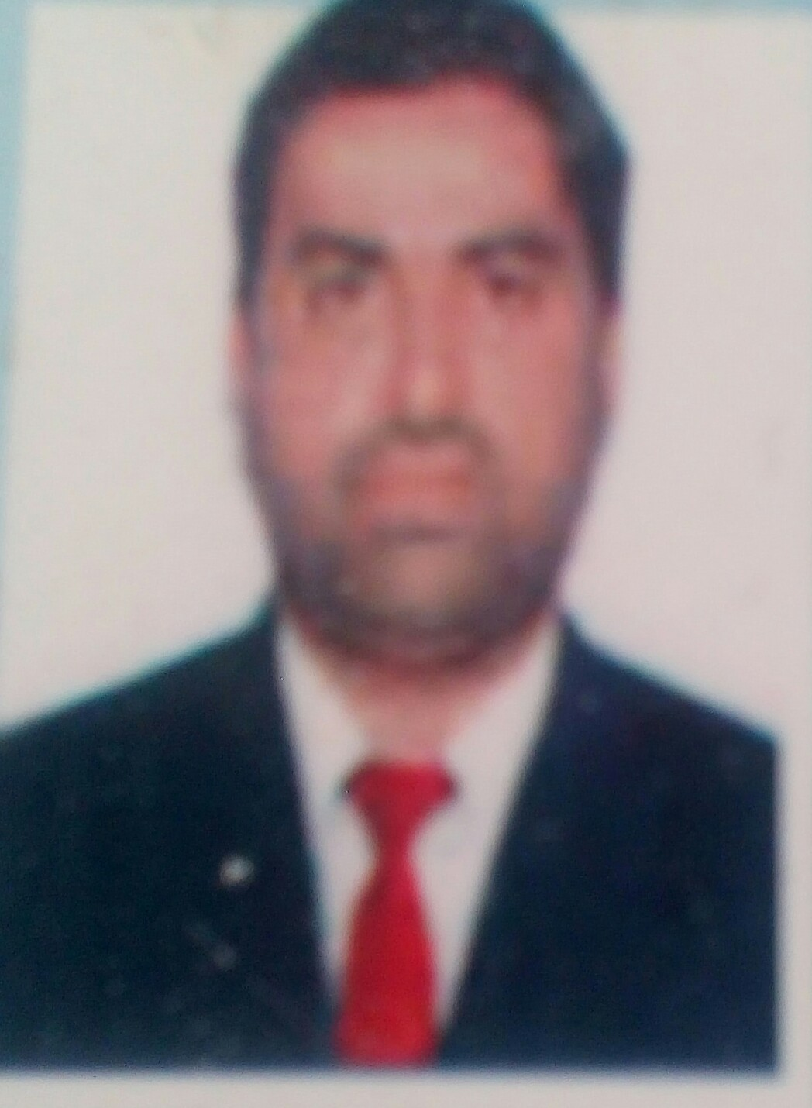GHAZI MOHAMMAD BAQAR KOLACHI BALOACH

**Phone No: +92-3213507818**

**Email:** [**kolachi_raja@yahoo.com**](mailto:kolachi_raja@yahoo.com)

**Address: House# 150, sheesham colony Luqman Khairpur Mir’s.**

**Overall 13 years of Experience in Oil & Gas Onshore Well Head & Compressor as Instrument Engineer**

**GASCO Engineering Pakistan:**

from May 2009 to Dec2020

11 Year Experience as Instrument Engineer” at *“Kadanwari gas field“* . Kadanwari Gas Field is operated by Eni Pakistan Ltd. O & M Contract of wellhead compressors is with GASCO Engineering, Pakistan. Due to decreasing wellhead pressures; Compression Phase of Kadanwari Gas Field has been started since 2004. Compression facilities consist of 8 Reciprocating Double Acting Two / Four Stages Compressor manufactured by CAMERON Superior MH62/RAM54 Compressor with unit control panel by Murphy. Compressor is driven by Cater Pillar / Waukesha/AJAX Gas Engine

**SALES AND SERVICES INTERNATIONAL PAKISTAN:**

(Jan 2020 to till date)

Working as Instrument Engineer

from 2020.

SSI Pakistan is contractor of PRIME Pakistan ( formerly Eni Pakistan).

**Job Description**

* Monitor all field equipment’s and ensure their proper functioning including compressors, generators and Flow lines.
* Ensured that all wells are producing at maximum rates.
* Examined proper lubrication and functioning of pumps and rotary equipment’s.
* Timely preparation of equipments for maintenance activities including isolation, depressurization and flushing.
* Performed line surveys and leak detection for flow line integrity monitoring.
* Identify, correct and report any unsafe condition to field Supervisor
* Assisted other operators and technicians in operating Plant/Wellhead equipment during emergency.
* Isolate and LOTO plant equipment’s for maintenance jobs.
* Gives on job trainings to junior/trainee operators.
* Perform as member during emergency of Fire/Gas release.

**Field and Well operations**

* Wellhead compressor Operations- commissioning, shutdown, chokes adjustments as per guidelines
* Separators & Slug Catcher operations
* Gas Compressors ( Reciprocating)
* PD and centrifugal Pumps operations
* Corrosion Inhibitor Injection and treatment of Flow lines
* Water treatments, Disposal and injection System
* Shutdown and Commissioning of Oil and Gas wells and fields.
* Proficient with P & IDs and PFD, Cause & Effect and Fire detection system.

**Qualification:**

**BE (Electrical Engineering)**

**Passing year 2008**

**PEC# Electrical 25736**

**PROFESSIONAL TRAININGS**

* Permit to work
* Authorized Gas Tester
* Fire Fighting, Working at height, confined space entry attendant
* First Aid

**PERSONAL DETAILS**

Nationality : Pakistani

Domicile: kKhairpur Mir’s

CNIC No : 45203-0821700-9

Gender :Male

Languages Known : English, Urdu, Seraiki and Sindhi.